Question 2 Report
Title -2
Analysis of Multi-Stage Authentication Using the Substitution Method

Aim
To solve the recurrence relation
$$T\left(n\right)=T\left(n/2\right)+1$$
using the substitution method, implement the recursive algorithm in Python, and determine its time and space complexity.

Problem Statement
A security authentication system reduces the problem size by half during each recursive stage while performing constant verification work.
Algorithm
- Start.
- Read the value of n.
- If n ≤ 1, return 1.
- Otherwise, recursively call the function with n/2.
- Add one verification step.
- Display the number of verification levels.
- Stop.

CODE:
def authentication(n):
if n <= 1:
return 1
return authentication(n // 2) + 1

n = int(input("Enter authentication size: "))

result = authentication(n)

print("Verification Levels =", result)

Input
16

Output
Enter authentication size: 16
Verification Levels = 5

ScreenShot
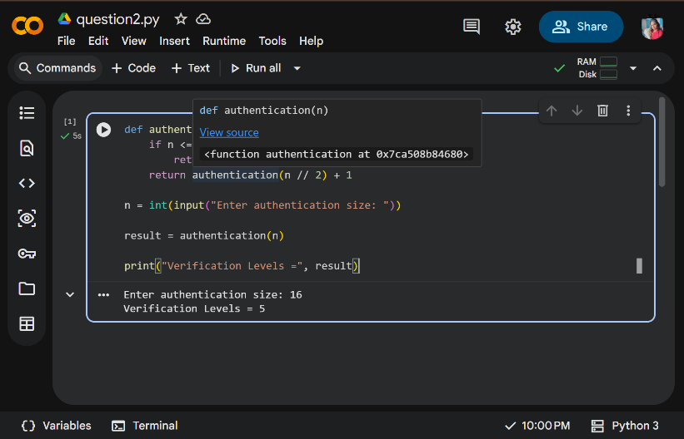

Substitution Method
Given
$$T\left(n\right)=T\left(n/2\right)+1$$
Expand,
Step 1
$$=T\left(n/4\right)+1+1$$
Step 2
$$=T\left(n/8\right)+1+1+1$$
Step 3
$$=T\left(n/2^{k}\right)+k$$
Stopping condition
$$\frac{n}{2^{k}}=1$$
Therefore,
$$2^{k}=n$$
Taking logarithm,
$$k=\log_{2}n$$
Hence,
$$T\left(n\right)=T\left(1\right)+\log_{2}n$$
Since
$$T\left(1\right)=1$$
Therefore,
$$T\left(n\right)=1+\log_{2}n$$

Time Complexity
Each recursive call reduces the input size by half.
Number of recursive calls
$$=\log_{2}n$$
Therefore,
Time Complexity = Θ(log n)

Space Complexity
Each recursive call occupies one stack frame.
Depth of recursion
$$=\log_{2}n$$
Therefore,
Space Complexity = Θ(log n)

Asymptotic Notation
- Big-O: O(log n)
- Big-Theta: Θ(log n)
- Big-Omega: Ω(log n)

Analysis
The algorithm reduces the problem size by half during each recursive call while performing constant work. As a result, the number of recursive levels grows logarithmically, making the algorithm highly efficient even for very large input sizes.

Conclusion
The recurrence relation was solved using the substitution method. The recursive implementation was verified successfully. The algorithm has a time complexity of Θ(log n) and a space complexity of Θ(log n), making it suitable for scalable authentication systems.

